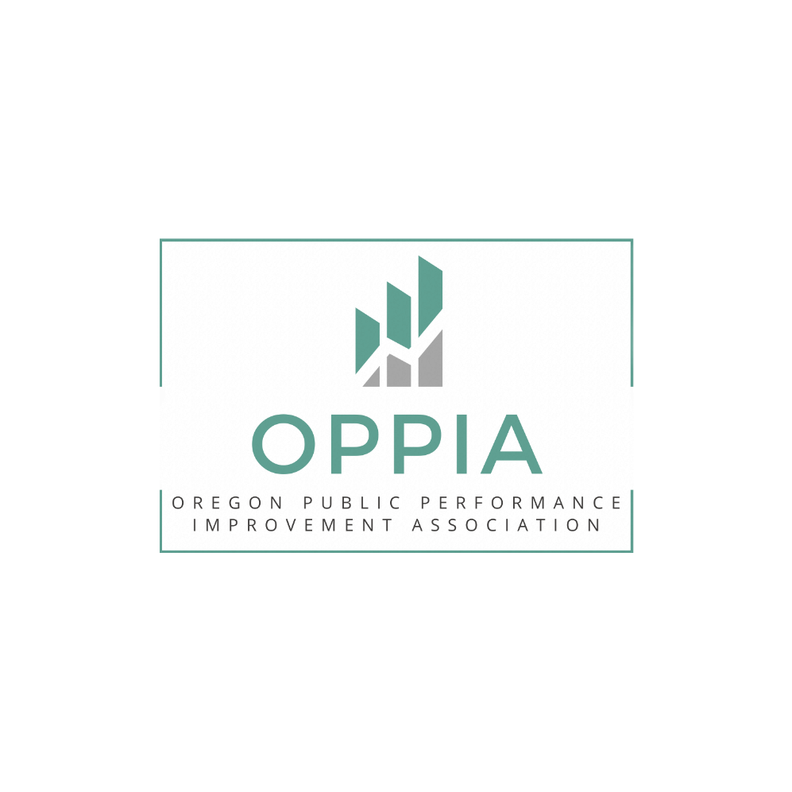
Board Recruitment Prospective Member Questionnaire
Please provide brief answers to the following questions – and e-mail the completed questionnaire to OPPIA at oregon.oppia@gmail.com.
Name: ___________________________________ Employer: __________________________________
E-mail: ___________________________________ Phone: ______________________________________

- Briefly describe why you are interested in serving on the OPPIA board, and what you feel you are willing and able to contribute to the work (professional networks, knowledge/skills, and time/resources).

- Please describe your most significant experiences using or working with performance measurement/management and why you feel it is significant.

- Please describe where you see the field of performance measurement/management heading in the future, and what you feel the potential of OPPIA is to positively influence that.

- What are some of the events/activities/products/services you think the OPPIA should consider (in addition to lunch and learns and the annual event) to achieve its full potential?

