Count Your Change
  - Next Steps in Public Performance Improvement
Conference Agenda: Day 1

Tuesday, August 3
Time | Topic
9:00 AM | Introduction and Welcome  Dr. Kenneth Smith, OPPIA Chair
9:10 AM | Be(Come) an Awesome Improver  Dr. Lisbeth Claus, International HR Expert and Agile Leader, Author of “Be(Come) an Awesome Manager: The Essential Toolkit for Impact Leadership”  - 60 minutes, including Q&A
10:10 AM | Break
10:20 AM | Difference Process Protocols-that Aren’t Really that Different  Steve Zagarola, Founding Partner of Northwest Center for Performance Excellence and Executive Master Six Sigma Black Belt  - 50 minutes, including Q&A
11:10 AM | Panel on Data Management/Business Intelligence  Moderator: Jameson Watts, Willamette University  Panelists: Stevan Gorcester, Former Director of the Washington Transportation Improvement Board; Becca Bourson, Oregon Dept. of Transportation; Casey Ragain, Oregon Dept. of Transportation  - 50 minutes, including Q&A
Noon | Lunch (bring your own!) & Networking  Talk with our keynote speakers and network with conference attendees  - 60 minutes

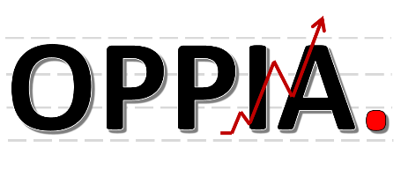
2021 Summer Conference
Oregon Public Performance Improvement Association
https://www.oppiaoregon.com/
Conference Agenda: Day 2

Wednesday, August 4
Time | Topic
9:00 AM | Introduction and Welcome  Bandon Cobb, OPPIA Chair-Elect
9:10 AM | Performance Improvement Across Levels of Government and Non-Profit Organizations  Janet Carlson, PhD, Former Marion County Commissioner and State Legislator  - 60 minutes, including Q&A
10:10 AM | Break
10:20 AM | Panel on Change Management  Moderator: Matt Rosen, Oregon Youth Authority  Panelists: Dr. Andre Lockett, Oregon Youth Authority; Lisa Martinez, Oregon Department of Transportation; Christal Lee, Oregon Lottery; Nina Junco, Oregon Department of Transportation  - 50 minutes, including Q&A
11:10 AM | Communicating Performance  Moderator: Dr. Kenneth Smith, School Accountability Group  Panelists: John Kurpierz, York University; Phoebe Klaer & M. Shane Pruett, Ph.D., DHS  - 50 minutes, including Q&A
Noon | Lunch (bring your own!) & Networking  Talk with our keynote speakers and network with conference attendees  - 60 minutes

2021 Summer Conference
Oregon Public Performance Improvement Association
https://www.oppiaoregon.com/

At the end of the conference, please remember to complete your conference evaluations
Count Your Change
  - Next Steps in Public Performance Improvement
Session and Speaker Information

Be(Come) an Awesome Improver
Conference Keynote Speaker: Lisbeth Claus
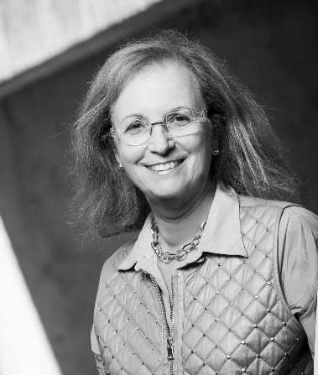
Ph.D., SPHR, GPHR, SHRM-SCP
Management and Global HR
Professor Emerita, Willamette University, USA
Visiting Professor, Pforzheim University, Germany

Dr. Lisbeth Claus has published more than 100 articles about international HR in academic and professional journals. She specializes in the implications for global organizations when their employees cross borders.
She is co-author of a number of books: #ZigZagHR: Why the Best HR is no Longer HR (with Lesley Arens), Global Immersion Press, 2019; #ZigZagHR: Waarom de Beste Hr Geen HR Meer is (with Lesley Arens), Pelckmans Pro, 2018; International Human Resource Management, 3rd edition (with Dennis Briscoe and Randall Schuler), Routledge, 2008; and is Editor-in-Chief of the four-volume Global HR Practitioner Handbook (Global Immersion Press, 2013, 2014, 2015, 2018).
Considered the premier global expert on employer duty of care, she traveled to four continents to inform employers of their obligation to protect their business travelers, international assignees, and dependents. She is the author of the 2009 International SOS Duty of Care White Paper viewed today as a major impetus for putting duty of care on the map for global organizations. She authored the 2012 Duty of Care and Travel Risk Management Global Benchmarking Study, the first empirical study on duty of care for which she earned the EMMA award for research of the year.
Other areas of research interest include implementation of progressive HR practices, HR analytics, resilient career development, and the development of a culture of health and wellbeing in international organizations.
A native of Belgium, she is fluent in Flemish, French, and English and has a working knowledge of German.
Foremost an educator, she has inspired thousands of learners—graduate students and practitioners—to better navigate the global scope of management.
Contact:
lclaus@willamette.edu
https://www.linkedin.com/in/lisbeth-claus-3634661/

Difference Process Improvement Protocols – that Aren’t Really that Different
Steve Zagarola
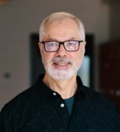
Improvement gurus all love their acronyms – PDCA, PDSA, RCQI, DMAIC, DMAVD, IDOV, 8D, A3, TQM, LSS, 5S, SIPOC, VSM, and --- on, and on, and on. Some of the acronyms refer to tools, others to methodologies, others to protocols. In this presentation you will learn about four acronyms representing four “different” process improvement protocols -- PDCA, PDSA, RCQI, DMAIC. The presentation brings perspective to the protocol and its role, explains each and their strengths and weakness, compares them to each other and to the “Scientific Method”.
At the end of the presentation conference participants will understand the role of the process improvement protocol and how to use it. Plus, they will have the information to draw their own conclusions –
- Are they really different?
- Which is best?
- When do I apply which or is that really an important question?
- What are the pitfalls?
- How to ensure any process improvement protocol is effective?
About our speaker:
Steve Zagarola is a Six Sigma Executive Master Black Belt personally certified by Mikel Harry, the co-founder of the Six Sigma methodology. Steve is a founder and the Managing Partner for the Northwest Center for Performance Excellence (NWCPE.) He is also a founder and instructor for Lean and Six Sigma for Professional Education programs at PSU and OSU in Portland and The Universidad de San Francisco de Quito’s in Quito, Ecuador. He served as a technical editor for the latest edition of “Six Sigma for Dummies” book and has published hundreds of articles and papers in trade journals and newsletters.
He has more than 30 years’ experience in the practical application of statistical and modern structured approaches to the optimization of manufacturing and transactional processes, quality systems and R&D. Prior the founding of NWCPE, Steve served as the Director of Quality for Cascade Microtech (now, Form Factor) – a provider of test probes and probe stations for the development of advanced semi-conductor devices, for Vestas Wind Systems as Quality and Six Sigma Program Manager, and a Senior Manufacturing Manager for The Coca-Cola Company.
Steve has provided training and consulting for industries ranging from advanced semi-conductors, food and beverage, plastics molding, and wind energy on six continents and in English, Spanish, Italian and German.

Performance Improvement Across Levels of Government and Non-Profit Organizations
Janet Carlson
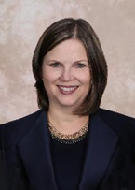
Governments oversee significant resources targeted to improve our lives – through health care, social services, education, and parks, to name just a few. Yet, when delegating funds and authority from federal to state to regional and local government levels – and then to nonprofit organizations under government contract – performance isn’t guaranteed. This session will engage participants in exploring how performance can be made more likely to succeed by paying attention to system design, capacity, and leadership issues.
At the end of the discussion, conference participants will better understand the interrelated roles of governments and service providers at all levels. Warning: the discussion may raise even more questions that will require additional pondering!
About our speaker:
Janet Carlson, PhD, is a consultant and board administrator for the Mid-Willamette Valley Homeless Alliance, the Marion-Polk region’s Continuum of Care. From 2003-2019, she served as an elected Marion County Commissioner, and as an Oregon state representative from 2001-03. Janet earned a BA in political science (summa cum laude) at Willamette University, an MA in political science at Brigham Young University, and a PhD at the University Oregon in special education and community resources. Since 1991, her involvement with Oregon’s children and families system has included serving in policy, administrative, consultant, and evaluator roles.
Janet is a past president of the Association of Oregon Counties, chaired the Willamette Valley Community Health board of directors, Marion County Public Safety Coordinating Council, Mid-Valley Behavioral Care Network board of directors, Local Government Advisory Committee to the Oregon Health Authority and Oregon Department of Human Services, and actively served on many other task forces and councils focused on workforce development, community corrections, education, health care, and housing.
Janet began her career as a junior high teacher and later taught courses at Oregon State University, Western Oregon University, Willamette University, and Portland State University.

Panel Descriptions
Panel #1: Data Management/Business Intelligence: This session talks about data informed performance improvement, going beyond the dashboard. Examples include a 6th generation website from the Washington Transportation Improvement Board using free software, a mobile device application used to track work in the field across geographic locations, and a series of tools using GIS (Geographic Information System) for different aspects of managing funding and transparency for Safe Routes to Schools.
Panel #2: Panel on Change Management: This session discusses the enormous value change management brings to any organization that relies on the behavior of people to be successful. Panelists will be talking through the structures/investments required for implementation; how one gets started; and the continuing issues that come up throughout the change management process.
Panel #3: Communicating Performance: This session explores the past, present, and future of reporting governmental performance information. The past begins at least as early as 1907 with the Bureau of Municipal Research and there were significant changes in the 1930’S, 1970’S, 1990’S, and this century. For the discussion of the present, we delve into a case study from DHS’s office of Training, Investigations, and Safety (OTIS). For the future, we explore a series of known challenges and unknown terrain.

